Myarc Geneve 9640 384K RAM Installation

Original design and concept - Don Walden, Cecure Electronics (1997?)

Documented week of 5/20/2006 - 5/27/2006 by Tim Tesch

History:
The 384K modification was originally installed using three 128K RAM chips and the LS138. While similar, the installation required a little more work and a case modification.

During my employment at Cecure, I installed the original modification on a "fair" number of Geneve's. I did not consistently date and initial cards I repaired or upgraded until roughly a year before Cecure's demise. I usually place the initials and date near or under the gate array. I am certain my doing so did not increase the value of any card (darn!) but the practice remains all these years later.

I do not recall whether or not I installed the 512K chip at Cecure. My research notes outline the use of the diodes and how the memory map would need to be configured. Beyond that, my memory is vague.

This project is not an easy one to complete. I rate it about a 9.0 on a scale of 1-10, 10 being most difficult. However, once complete, the extra on-board RAM is a wonderful addition to the Geneve.

A Jeweler's Loupe is an excellent tool to review traces, solder pads, solder joints, and more. I use both a 5x and 10x loupe of this particular style:
http://www.widgetsupply.com/page/WS/PROD/05x-magnifier/SAA5-5XCL

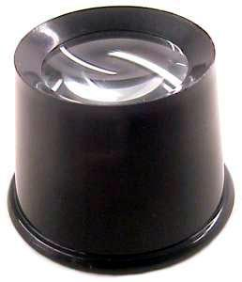

I recently ran across this device and was contemplating buying it. To make the best use, you need to buy the headband. I bet it would beat holding the simple loupe in place, and the swivel lens is a nice addition.

http://secure.cartsvr.net/catalogs/catalog.asp?prodid=627300&showprevnext=1
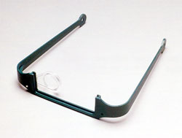

Parts Required
1 - 512MB 32-pin DIP SRAM
1 - 32 PIN DIP Socket. I use double-wipe sockets; Richard has performed the mod with machine socket.
1 - 28 PIN DIP Socket (optional, SRAM)
1 - 16 PIN DIP socket (optional, sound chip)
1 - 74LS138N
3 - N1N diodes
1 - 1K resistor
2 - Tie Wrap (?)
solder (note: do NOT use organic core)
30AWG solid, not stranded, wire - Red, White, Blue

Tools Required:
flat-head screwdriver
wire cutter
solder iron
desolder station (or comparable)
5x or 10x jeweler's loop to inspect the work
needle-nosed pliers

1. Preparation - Phase I
Preparatory work is the most important step when starting a project. Before performing any work, one must ensure the "subject" is in proper working order. Therefore, we'll inspect the Geneve!

a. Visual Inspection
i. First things first. Is the RAM socketed or soldered? Most Geneve's were built with a socket, but on rare occassion I have found RAM soldered to the board. If it is socketed, great! If not, you may or may not wish to perform this modification.

ii. Secondly, is the sound chip socketed? The sound chip is the second chip down, right-hand side of the picture. [SN76496N]. The picture shows a socketed sound chip; my test case was NOT socketed, so I had to remove the chip from the Geneve and install a socket. Again, if this it is socketed, great! If not, you'll partake of more preparatory work.
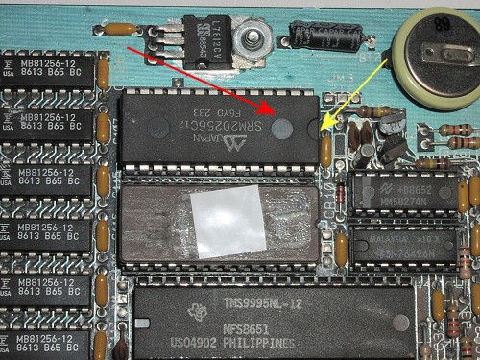

b. Test the Geneve
Verify PEB power is turned *OFF* for 2 minutes before you remove or insert a peripheral card!

- Place the Geneve into your PEB with any required peripherals (disk controller minimum)
- Boot the Geneve with MDOS 2.21 or above
- At the command prompt type "MODE 40" as needed (40 column mode)
- Perform a "CHKDSK" on any available floppy drive. (Example: "CHKDSK A:") and confirm the correct amount of RAM is present for your current configuration.
- Run MEMTEST and confirm that all memory is accurately accounted for and that no partial pages, missing pages, or otherwise "bad" things show up.
- Turn off the Geneve.
- Proceed to step 2.

2. Preparation - Phase II - naughty Geneve
If the Geneve successfully passed the boot and memory tests, and the RAM and sound chip are socketed, you may proceed to step 3. Otherwise, you must desolder one or both chips from the circuit board.

* Desoldering chips or through-holes must be done carefully, patiently, and ever so gently. Geneve traces and through-holes (the metal which interconnects the circuits) come in two flavors: acceptable and BRITTLE. An acceptable card is susceptible to heat, but not easily harmed. A brittle card is highly susceptible to heat; traces will lift or shift, through-holes can be easily ruined, solder pads will detach from the board. If you begin modifying your Geneve and discover it is one of the brittle cards, please user EXTREME caution. It won't take much to make a difficult project worse. I do not recommend modifying a brittle card - though it CAN be done.

a. 32K SRAM removal / socket
- Carefully desolder the chip, pin by pin, from the Geneve. Gently pull the chip from the board. If it does not lift easily, go back and desolder any "stuck" pins
- Inspect the 28 through-holes and solder pads. They should be relatively clear of solder.
- Place 28-pin socket in the Geneve. Note the orientation of the socket "dimple". It should match that of the RAM (see Yellow arrow, figure 1)
- Solder each pin.
- Confirm that you have not bridged any pins. A continuity tester will work wonders here.

b. Sound Chip Removal
- Carefully desolder the chip, pin by pin, from the Geneve.
- Gently pull the chip from the board. If it does not lift easily, go back and desolder any "stuck" pins.
- Inspect the 28 through-holes and solder pads. They should be relatively clear of solder.
- Place socket in the Geneve. Note the orientation of the socket "dimple" on the socket. It is the OPPOSITE of the RAM chip socket.
- Solder each pin.
- Confirm that you have not bridged any pins. A continuity tester will work wonders here.

c. Proceed to step 3 if you need to remove one of the two chips from a socket.

3. Preparation - Phase III - Good or Better Geneve
a. Remove 32K from socket
- If there are TWO chips in the socket, and a wire attached to one of the pins, you are the proud owner of a 64K SRAM. You must first remove the wire - I suggest desoldering from the gate array. The yellow wire pictured below is the 64K SRAM wire. Desolder it, then CLIP the exposed wire. This will make it easy to remove the chips.
- 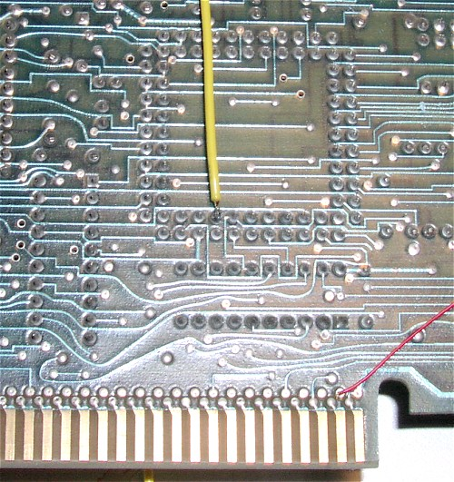
- Remove the 32K chip from its socket using a flathead scredriver. Gently pry underneath each side until the RAM is loose. Do not pry only one side!
- Set aside the RAM and attached wire. You may need it for another project.

b. Remove the sound chip from its socket using the same process, an set aside.

4. Preparation - Phase IV - Solder Removal
We will need to route wires through unused holes in the board. To do so, the solder must be removed. Using your desolder device, remove the solder from the following locations:

a. Remove solder from through-hole above C128, to the left of Q5.
b. Remove solder from through-holes 2 and 3, JM3.
c. Remove solder from through-holes 1,2,3 of JM1

5. Preparation - Phase V - Sound chip and LS138
Assuming you purchased a LS138, you will need to gently bend the legs inward so that when stacked atop the sound chip, all legs make "snug" contact. Failure to do so may result in poor connections or solder cracks.

a. Bend Leg 4 90 degrees counter-clockwise so that it is touching leg 5. (See picture)
b. Solder at this connection

c. Stack the chips; the flat surfaces must touch. Ensure the dimple is oriented the same direction.
d. Slder pins 5,8, and 16.
e. CLIP the narrow lead from pins 1,2,3,6,7 and 9,10,11,12,13,14,15 from the LS138. DO NOT CLIP ANY SOUND CHIP LEADS!
f. Carefully bend legs 9,10,11 (previously clipped) 90 degrees horizontal.

6. Affixing Diodes to the LS138
See note in step 7 before continuing.

a. Tin (apply small amount of solder) each leg, as close to the body of the chip as possible.
b. Using a small snips/wire cutter, CUT all but 1/4" of the lead from each diode. You will be cutting the lead on the banded end.
c. Solder one diode, clipped end, onto the tinned portion of pin 9. Repeat with remaining diodes to pins 10 and 11.
d. Bend diode leads 10 and 11 at a 90 degree angle towards pin 9. Clip the bent leads, then solder all three together.

7. Affixing wires to the LS138
This step is one of the more difficult, though not as difficult as socket preparation. Still with me? Good!

Note: It may be easier to attach the wires first.

a. Cut four wires, approximately 10" long, using the following colors:
Pin 1 - Red wire
Pin 2 - White wire
Pin 3 - Blue wire
Pin 6 - White Wire

b. Strip approximately 1/8" of plastic from one end of each wire.
Hint: I often use the soldering iron to "strip" the plastic. To do so, grab a piece of thin cardboard or use the back of the wire "container". Place the wire on the cardboard, then put the soldering tip on the wire. Apply pressure to the wire, and move the soldering point away from the wire. The pressure will force the melted plastic into the cardboard. You must be fairly quick, or you will melt too much plastic. Clip excess wire as needed.
c. Tin the snipped legs of pins 1,2,3,6.
- Do not use too much solder!
- Do NOT bend the pins like you did in step 5f.
d. Solder the wires to the appropriate pins. If you have tinned the leads with enough solder, you will not need to apply additional solder. This is preferred to prevent cold solder joints and melted wire insulation!
e. Verify no solder bridges exist.

8. 32-pin Socket Prep (Difficulty level - 9.0)
I believe Richard Bell uses a machine socket; it may in fact be easier. However, I can only document what I know ;)

a. Grab your 32-pin socket. Carefully bend pins 1,2,30,31,32 inward 90 degrees.
b. Cut 5 wires, approximately 10" long, using the following colors:
Pin 1 - White
Pin 2 -Blue
Pin 30 - Red
Pin 31 - Red
Pin 32 - Blue

c. Strip approximately 1/4" - 3/8" insulation from one end of each wire.

d. This next part is tricky. In the past I have inserted the memory chip into the socket prior to soldering the 5 wires. This usually helps, but when it comes time to remove the memory from the socket, more often then not I break a solder connection. So, I have learned to do without. When soldering, the socket pins have a tendency to "slip" out of the socket. If this happens, gently push it back down and continue.

d. Using a small needle-nosed or a thin diameter shaft (a larger paperclip will do) form a twist in one of the exposed wires.
e. Place the socket leg through the twist in the wire. Using a blunt-tipped screwdriver or your trust flat-head, gently try to wrap the wire around the leg a bit more. Be careful not to bend the wire too tightly or it may break.
f. Apply heat where the pin has been bent, apply solder, and gently depress into the plastic portion of the socket. You want to ensure the wire and pin are not able to make contact with anything else. This is important primarily for pin #30.
g. Finish the remaining wires in the same manner.

9. Install 32-pin socket and 3 of 5 wires
We will be installing the socket into the existing (or new) 28 pin SRAM socket. We will also use two tie-wraps to secure the socket, however, we will NOT secure it until the connections have been verified.

a. The wires from pins 1, 2, and 30 should be routed to the left.
b. The wires from pins 31 and 32 should be routed to the right.
c. Place the 32 pin socket on top of the 28-pin socket, with the 5 wires routed appropriately.
d. The wires should be routed to avoid binding.
e. Gently press the 32-pin socket into the 28-pin socket.
f. Wipe your brow.

* SEE LAST STEP - END OF DOCUMENT - BEFORE CONTINUING *

g. Locate JM3. (Previously desoldered the two holes.)
h. Identify the two wires you routed to the RIGHT (red and blue, pins 31 and 32)
i. Leave approx 2" slack and snip the wires.
j. remove 1/4" insulation from the ends
k. Solder RED wire into JM3, pin 3 (right hole)
l. Solder BLUE wire into JM3, pin 2 (left hole)
m. Verify continuity before proceeding:
- Pin 32 should now be connected to +5 volt. Test between pin 32 and regulator pin #3
- Verify this same pin, #32, is NOT grounded. Test between pin 32 and regulator middle lead.
- Pin 31 should have continuity with solder point in upper left-most corner of card.

n. Identify the three wires you routed to the LEFT
o. Solder Blue wire to JM1, pin 3, leaving approximately 1" slack.
p. Test continuity between JM1, pin 3, and socket pin #2
q. Feed RED wire through hole #2
r. Feed WHITE wire through hold #1

WHEW. Getting closer....

10. Install the LS138/sound chip combo!
Now it's time to install the 138/sound chip.

Note: It may be easier to snip the excess diode lead and use a piece of wire to make the next connection. I thought about this after the installation.

a. Place the stacked chips atop the sound chip socket. DO NOT PUSH IT INTO THE SOCKET YET
b. Using a needle-nosed pliers, bend the remaining diode lead 90 degrees toward the desoldered hole.
c. Make a second bend 90 degrees down. You may need to lift the chip to do so. The two bends will allow you to insert the lead into the hole.
d. Line up the LS138/sound chip with the socket, line up the diode lead, and route the four wires to the left towards the LED side of the card.
e. Gently push the chips into the socket.
f. DO NOT solder the diode lead at this time!
g. Route the 4 wires underneath CAP#85 (to left of EPROM/9995) then through the remaining holes in order:

h. Solder the wires as follows, leaving approximately 2" slack:
Pin 30 (RAM) + PIN 1 (LS138) to Pin 13, U29(LS244) [2x RED wires]
Pin 1 (RAM) + Pin 2(LS138) to Pin 15, U29 (LS244) [2 x White wires]
Pin 3 (LS138) to Gate Array pin #42 [Blue]
Pin 6 (LS138) to Gate Array pin #39 [White]

11. Test Continuity!
a. RAM (pin 30) to LS138 (pin 1)
b. RAM (pin 1) to LS138 (pin 2)
c. Two gate array wires

12. Install 1K pull-up resistor
Solder resistor between RAM pins 20 and 28. Be certain you do NOT count the capacitor as one of the pins!

Continuity: Pin 28 is +5V. Test between the pin and regulator output.

13. Cut CS (Chip Select) trace
Easiest place to cut the trace is near the card-edge connector "under" the 9901.

Follow the trace from point to point. CONFIRM the trace is now an open "circuit". You do not want continuity. The incision should be wide enough to counter and expansion of the metal due to heat.

14. Solder the diode lead
Solder the diode lead. Clip any excess.

15. FINAL STEPS
a. Check your work. If you have been working on this for a while, take a break! Come back in an hour and double-check all connections with your ohm-meter / multi-meter.
b. Confirm that none of the connections are grounded (test between solder point and middle leg of any regulator)
c. Confirm that no connections besides pin #32 (RAM) are connected to +5 or +12. Test between regulator output and connection.
d. Confirm no shorts exist between adjacent pins. Example: Test continuity between
RAM pins 31,30; 32,31; 1,2.
LS138 pins 1,2; 2,3; 5,6
LS244 pins 13,14; 14,15; 15,16

16. LAST STEP
In the past I have "fastened" the 32-pin socket at step 9. The only benefit to doing so is that if one of your wires is going to break, it will likely happen at this time. However, you may not know it until the continuity tests.

a. Slide tie wrap under socket from the left. Use a flat head screwdriver to guide the tie wrap upwards.
b. Ensure the three wires are closer to the 9995 (bottom) than the top of the card. Otherwise, your wires will have to route around the tie wrap. BAD idea.
c. Cinch the tie wrap.
d. Use the second tie wrap to fasten the MIDDLE portion of the socket. Do not try to fasten the right-end of the socket. Doing so usually results in a broken socket or disconnected wires.

17. OH Really? What about the RAM?
Oops. I suppose we need to put the RAM into the socket. Insert, careful of the orientation (dimple to the RIGHT). Confirm all pins are seated properly.

18. I REALLY DID IT -- I BETTER TRY IT OUT
Wow! Let's try it out!

a. Install Geneve and disk controller card. Suggest removing any memory peripheral cards (Memex, RAVE, etc)

b. Check memory from MDOS prompt:
CHECKDSK A: 907504 Total Bytes RAM (assuming no other memory cards installed)

c. Check memory via MEMTEST:
MEMTEST Fast RAM should show up in memory pages >C0 through >EF.

If you see FAST ram in pages between >40 and >BF, you probably made a mistake. (Assumption: no other memory devices installed in PEB)

19. CONGRATULATIONS!
You are now the proud owner of a 384K fast RAM Geneve!

