GenRef

v1.00

MDOS Reference guide.

KeyScan Library

(C) Copyright 2004
Beery W. Miller
ALL RIGHTS RESERVED
____________________________________________________________________________________
KeyScan - CONTENTS ____________________________________________________________________________________

KeyScan Overview 3
Calling KeyScan Functions 3
KeyScan Mode 4
KeyScan Mode 1 & 2 4
KeyScan Modes 1 through 6 5
KeyScan Mode Function Table 5

____________________________________________________________________________________
KeyScan - OVERVIEW ____________________________________________________________________________________

The KeyScan management routines in MDOS are provided to aid a programmer in writing applications requiring keyboard and joystic input. The Geneve supports keyboards utility up to 12 function keys and a separate keyboard.

____________________________________________________________________________________
CALLING KEYSCAN FUNCTIONS
____________________________________________________________________________________

The MDOS KeyScan Library must be called from within a machine code program running as a task under MDOS. You pass arguments to the KeyScan Library via the calling registers.

The MDOS KeyScan Library is invoked from a machine code program when software trap number zero (XOP 0) is called with a library number of 5. The calling program's R0 must contain the 16-bit subprogram at the time of the XOP.

SCAN LI R0,>0004 Scan Mode
LI R1,>FF00
XOP @FIVE,0 Access subprogram
JNE SCAN Wait for keypress

ANDI R1,>FF00

CI R1,>FF00
JEQ SCAN

* Check Keypress

ANDI R1,>7F00 Codes (usually) never higher than >F

* Note – If you do NOT perform the ANDI, control codes may start at >80 - >9F

MOVB R1,@STR Let’s display the character – place in buffer

LI R0,>0027 Write Text Routine
LI R1,STR1 String to write
CLR R2 Null terminated string
XOP @SIX,0 Access subprogram

BLWP @0 Exit

FIVE DATA >0005
SIX DATA >0006
STR1 BYTE >00
BYTE >0D,>0A,0 CR/LF/Null terminated
EVEN

In the preceding example, three hidden assumptions were made. First it is assumed that STR1 is located on a page which is currently mapped into a memory page which has the same 16-bit address page number as its Virtual address page number (read the section on Memory Management.) The second assumption is that FIVE and SIX are actually at the virtual address FIVE and SIX, not in some overlay segment with a different virtual address.
KeyScan Mode Library

KeyScan Mode

Function Returns key press from selected key mode.

Parameters R0x = Keyboard Mode

Results R0l = Returned mode (same as >8374 in TI-99/4A mode)
R1h = Returned scan code (same as >8375 in TI-99/4A mode)
R2l = Joystick X value (same as >8377 in TI-99/4A mode)
R2h = Joystick Y Value (same as >8376 in TI-99/4A mode)

EQ bit in status register set if there’s a new key in R0

Mode 7 EQ = 1 if Break On
Mode 8 Raw scan code returned in R1h
Raw code returned is >FF if no code in buffer
Parameter Description

Keyboard Mode >0000 USE LAST KEYBOARD MODE (MUST BE GOOD!)
>0001 USE LEFT SIDE OF KEYBOARD
>0002 USE RIGHT SIDE OF KEYBOARD
>0003 STANDARD MODE
>0004 PASCAL MODE
>0005 BASIC MODE
>0006 Reserved for Abasic
>0007 BREAK KEY CHECK
>0008 RAW KEY CHECK

Left (>0001) and Right (>0002) side of Keyboard Modes

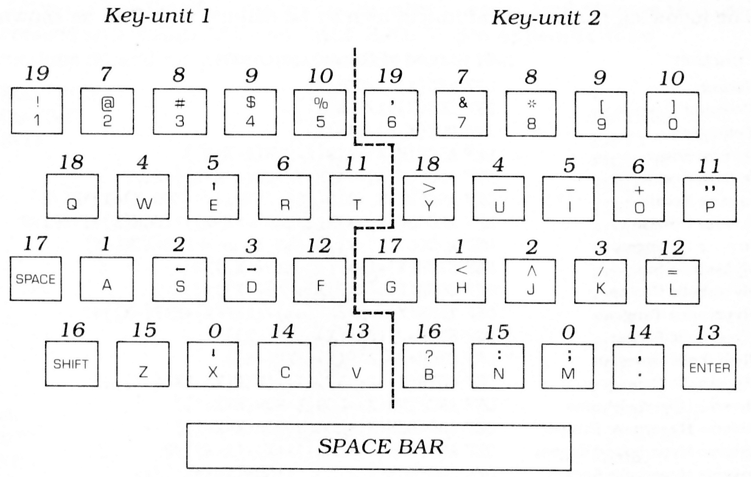

KeyMode 0 Console keyboard, in mode previously specified by the calling subprogram.
- Only the left side of the keyboard is active.
- Only the right side of the keyboard is active.
- Places keyboard in standard TI-99/4A mode. (Most command module software used this mode.) Both upper and lower case alphabetical characters are returned as upper-case only, and the function keys (BACK, BEGIN, etc) return codes 1 through 15. No control characters are active. If code > 96 and Code < 123 then add ->20. If Code > 126, then Kill it. If Code < 32 and Code > 15 then Kill it.
- Remaps the keyboard n the PASCAL mode. Both upper and lower case alphabetical character codes are returned by the computer, and the function keys return codes from 129 through 143. The control character codes are 1 through 31.
- Places the keyboard in 99/4A BASIC mode. Both upper and lower case alphabetical character codes are returne by the computer. The function key codes are 1 through 15, and the control key codes are 128 through 159 (and 187).
- This mode is reserved for MYARC Advanced BASIC mode and is not available to any MDOS programs other than ABasic. In addition to the normal ASCII codes returned in keyboard mode 5, the following additional Extended Codes are also returned in keyboard mode 6.

Extended Code  (Hex) | Function
3 | NUL Character
F | Back Arrow
10-19 | ALT Q,W,E,R,T,Y,U,I,O,P
1E-26 | ALT A,S,D,F,G,H,J,K,L
2C-32 | ALT Z,X,C,V,B,N,M
3B-44 | F1-F10 Function Keys (Base Case)
47 | Home
48 | Up Arrow
49 | Page Up
4B | Left Arrow
4D | Right Arrow
4F | End
50 | Down Arrow
51 | Page Down
52 | INS
53 | DEL
54-5D | F11-F20 (Upper Case F1-F10)
5E-67 | F21-F30 (CTRL F1-F10)
68-71 | F31-F40 (ALT F1-F10)
72 | CTRL PRTSC (Start/Stop Echo to Printer)
73 | CTRL Right Arrow (Reverse Word)
74 | CTRL Left Arrow (Advance Word)
75 | CTRL END (Erase to End of Line)
76 | CTRL PG DN (Erase to End of Screen)
77 | CTRL HOME (Clear Screen and Home)
78-83 | ALT 1,2,3,4,5,6,7,8,9,0,-,=
84 | CTRL PG UP (Top 25 lines of Text and Home Cursor

